Que:1

CREATE TABLE Student ( 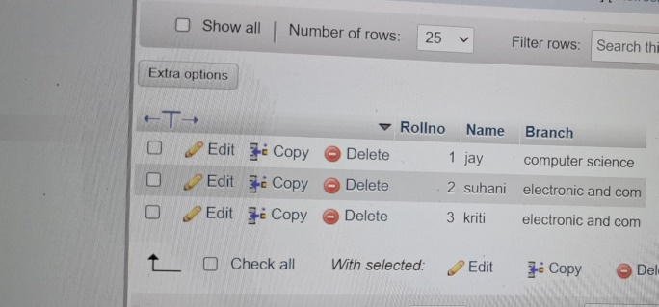

Rollno INT PRIMARY KEY,

Name VARCHAR(50),

Branch VARCHAR(50)

);

INSERT INTO student

VALUES (1,’jay,’computerscience’),

(2,’suhani,’electronic and com’),

(2,’suhani,’electronic and com’));

[SELECT](http://localhost/phpmyadmin/url.php?url=https://dev.mysql.com/doc/refman/8.0/en/select.html) * FROM `student`;

Now, Exam table detail :

CREATE TABLE Exam(

Rollno INT,

S_code VARCHAR(10),

Marks INT,

P_code VARCHAR(10)

);

INSERT INTO exam

VALUES(1,'CS11',50,'CS'),

(1,'CS12',60,'CS'),

(2,'EC101',66,'EC'),

(2,'EC102',70,'EC'),

(3,'EC101',45,'EC'), 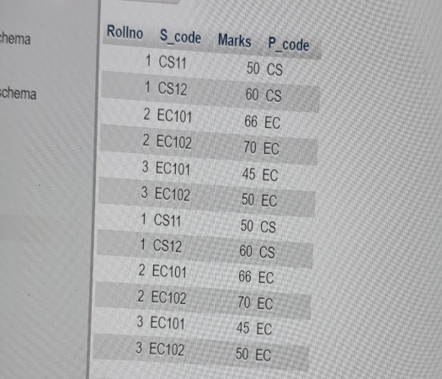

(3,'EC102',50,'EC');

SELECT * FROM exam;

FOREIGN KEY (Rollno) REFERENCES student(Rollno);

2)

create table employee(

EMPLOYEE_ID INT,

FIRST_NAME VARCHAR(50).

LAST_NAME VARCHAR(50),

SALARY INT,

JOINING DATE DATE,

DEPARTMENT VARCHAR(50)

);

INSERT INTO employee VALUES

(1,'john','abharam',10000000,'01-jan-13 12.00am','Banking'),

INSERT INTO employee VALUES

(2,'Micheal','Clarke',800000,'01-jan-13 12.00am','Insurance '),

(3,'Roy','Thomas',700000,'01-feb-13 12.00am','Banking'),

(4,'Tom','Jose',600000,'01-feb-13 12.00am','Insrurance'),

(5,'Jerry','Pinato',65000,'01-feb-13 12.00am','Insrurance'),

(6,'Philip','Methew',75000,'01-jan-13 12.00am','Service'),

(7,'p','J',500000,'01-feb-13 12.00am','Insrurance'),

(8,'Tod','Josp',600000,'01-feb-13 12.00am','Insrurance');

SELECT * FROM employee;

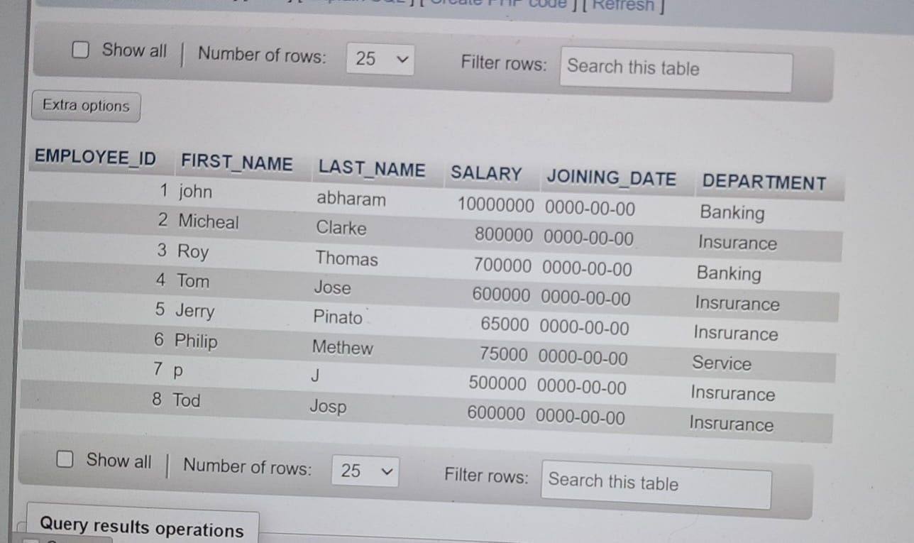

2)Incentive Table:

USE tops;

CREATE TABLE Incentive(

EMPLOYEE_REF_ID INT,

INCENTIVE_DATE DATE,

INCENTIVE_AMOUNT INT

);

INSERT INTO incentive

VALUES(1,'01-FEB-13',5000),

(2,'01-FEB-13',3000),

(3,'01-FEB-13',4000),

(1,'01-JAN-13',4500),

(2,'01-JAN-13',3500);

SELECT * FROM incentive; 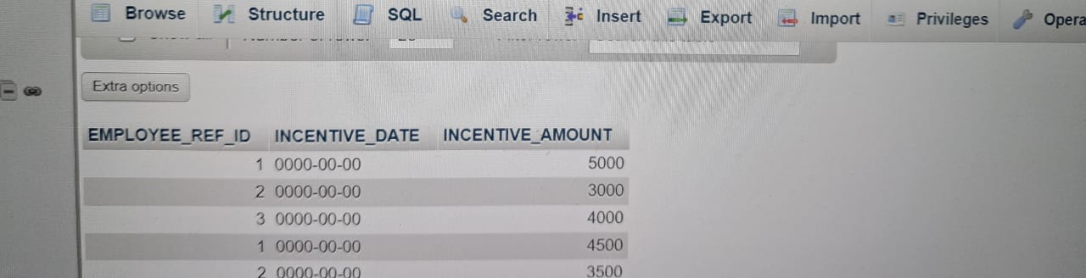

3) SELECT First_Name from employee WHERE first_Name='Tom';

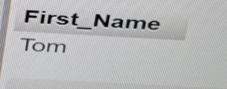

4) Get FIRST_NAME, Joining Date, and Salary from employee table.

SELECT FIRST_NAME,JOINING_DATE,Salary from employee;

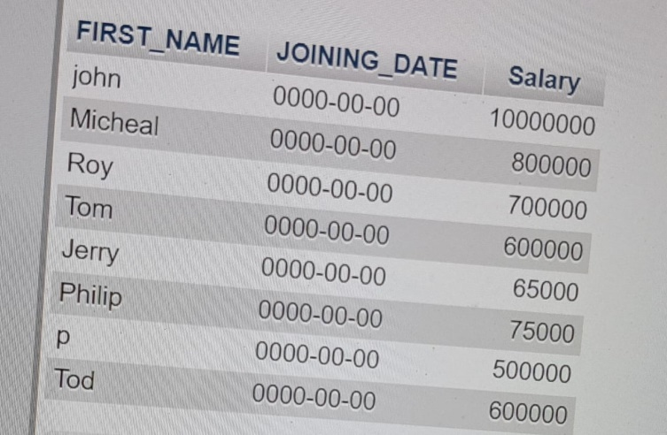

5. Get all employee details from the employee table order by First_Name Ascending and Salary descending?

SELECT * FROM employee ORDER BY EMPLOYEE_ID DESC;

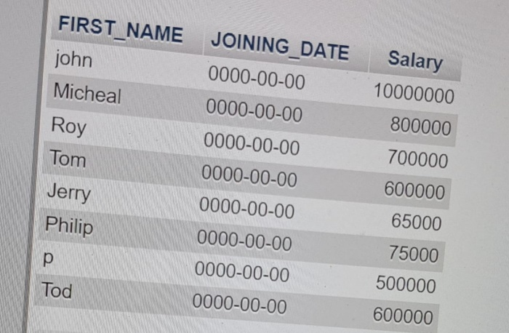

SELECT * FROM employee ORDER BY EMPLOYEE_ID ASC;

6. Get employee details from employee table whose first name contains ‘J’.

SELECT *FROM employee WHERE first_name ='J';

7)Get department wise maximum salary from employee table order by 8. salaryascending?

SELECT * FROM employee ORDER BY SALARY ASC;

9. Select first_name, incentive amount from employee and incentives table forthose employees who have incentives and incentive amount greater than 3000

Select first_name, 'incentive_amount' from employee;

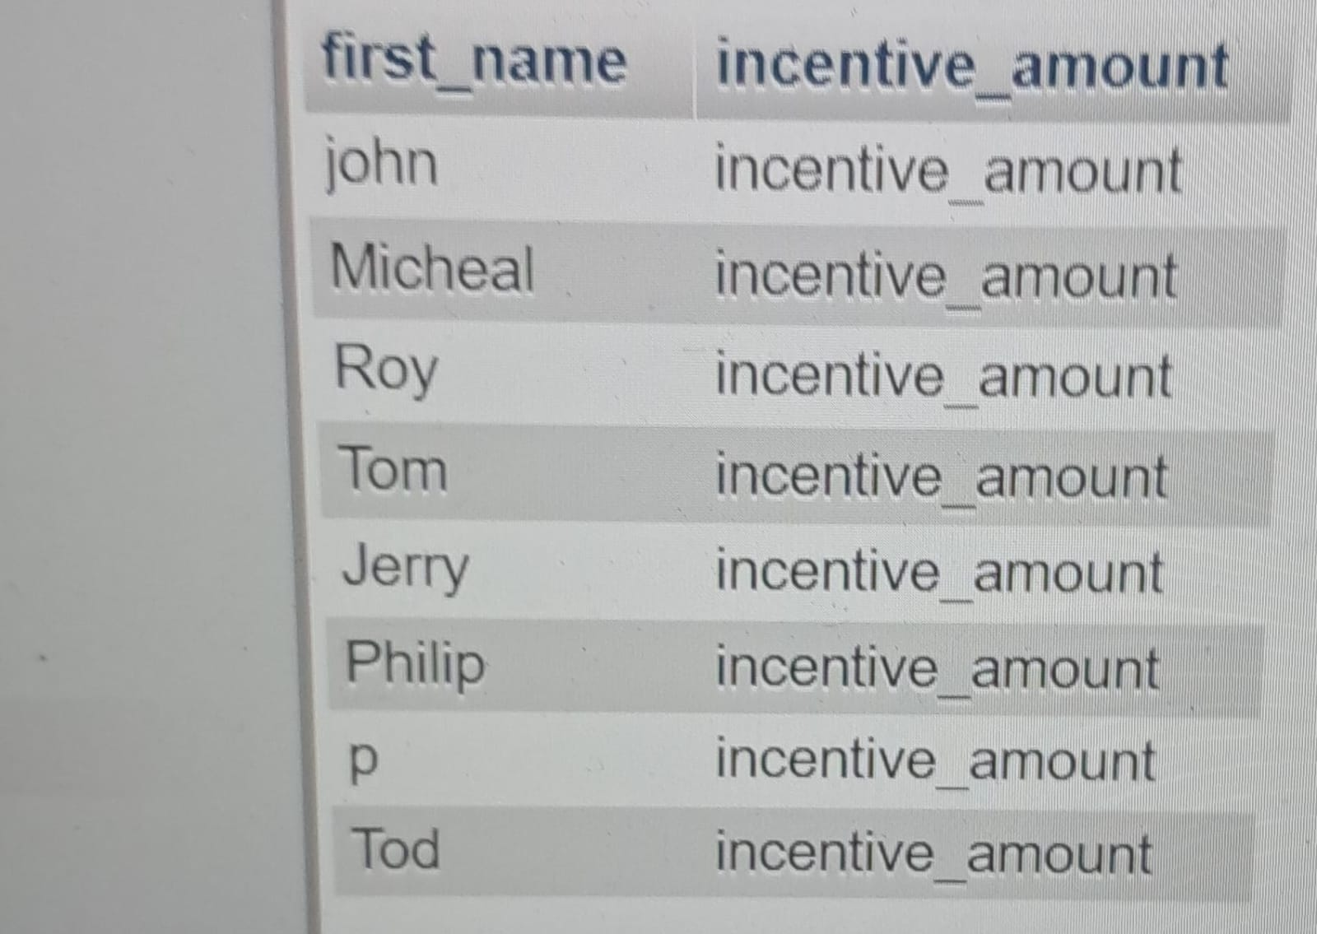

SELECT * FROM incentive where INCENTIVE_AMOUNT>3000;

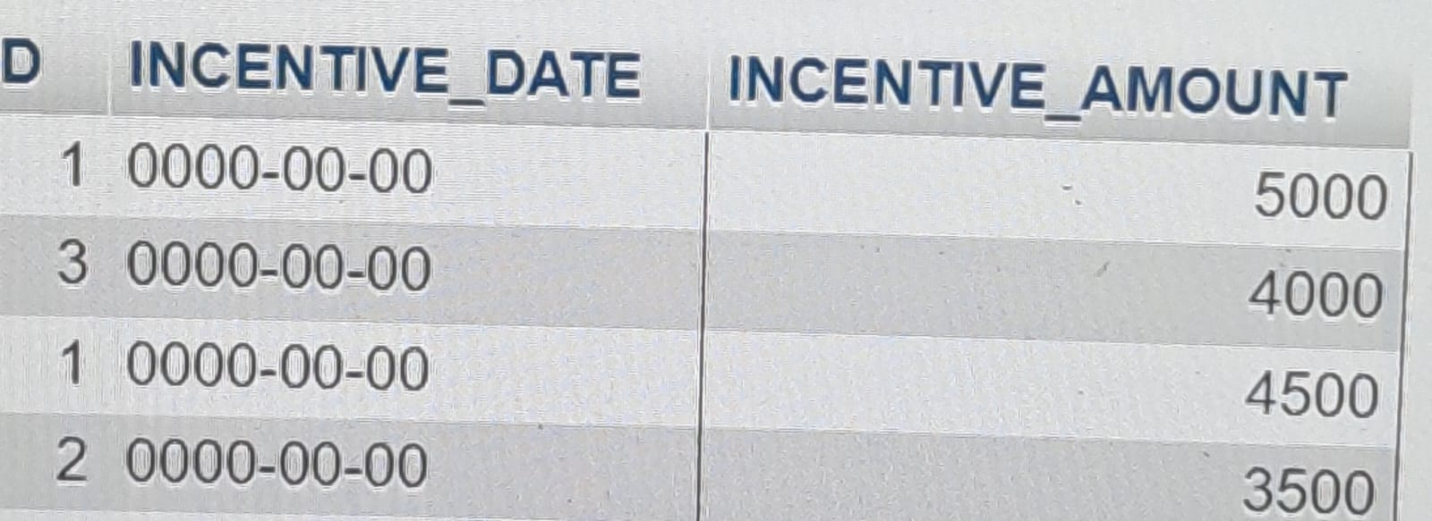

10. Create After Insert trigger on Employee table which insert records in viewtable.

create VIEWTABLE(

EMPLOYEE_ID INT,

FIRST_NAME VARCHAR(50).

LAST_NAME VARCHAR(50),

SALARY INT,

JOINING DATE DATE,

DEPARTMENT VARCHAR(50)

);

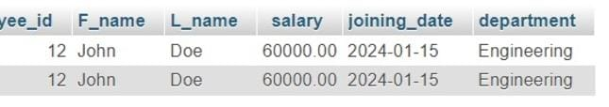

CREATE TRIGGER AFTER_EMPLOYEE_INSERTED

FOR EACH ROW

BEGIN

INSERT INTO viewtable(EMPLOYEE_ID,FIRST_NAME,LAST_NAME,SALARY,JOINING DATE,DEPARTMENT);

VALUES(NEW.EMPLOYEE_ID,NEW.FIRST_NAME,NEW.LAST_NAME,NEW.SALARY,NEW.JOINING DATE,NEW.DEPARTMENT);

11) Create table given below: Salesperson and Customer

CREATE TABLE salesperson(

SNO INT,

SNAME VARCHAR(50),

CITY VARCHAR(50),

COMM VARCHAR(50)

);

INSERT INTO salesperson

VALUES(1001,'peel','London',12),

(1002,'serrnes','san jose',13),

(1004,'motika','London',11),

(1007,'rafkin','Barcelona',15),

(1003,'axelrod','new york',1);

SELECT* from salesperson1;

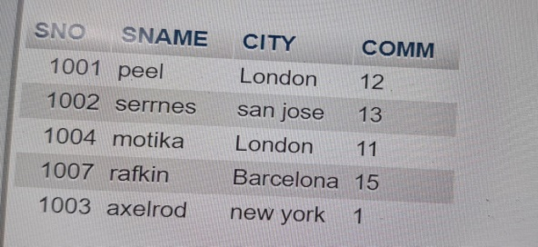

CREATE TABLE custOmer(

CNM INT,

CNAME VARCHAR(50),

CITY VARCHAR(50),

RATING INT,

SNO INT

);

INSERT INTO customer

values(201,'Hoffman','London',100,1001),

(202,'Glovanne','Roe',200,1003),

(203,'Liu','San jose',300,1002),

(204,'Grass','Barcelona',100,1002), 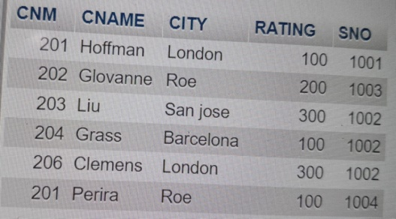

(206,'Clemens','London',300,1002),

(201,'Perira','Roe',100,1004);

SELECT * FROM customer;

13)

select CNAME FROM customer WHERE rating>100;

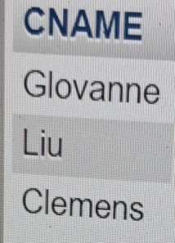

14) Names and cities of all salespeople in London with commission above 0.12

Select name,city from salesperson where city=’London’ AND comm>0.12;

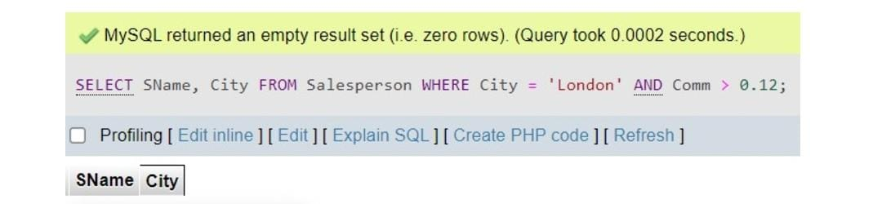

15) All salespeople either in Barcelona or in London

SELECT Name,City

From salesperson WHERE city=’Barcelona’ OR ‘London’;

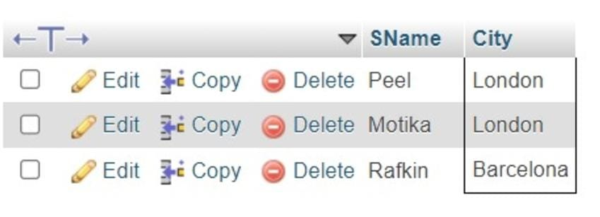

16) All salespeople with commission between 0.10 and 0.12. (Boundary values should be excluded).

SELECT SName,City,Comm

FROM salesperson

WHERE Comm>.10 AND Comm<0.12;



17)

SELECT CName,City,Rating

FROM customer

WHERE Rating> 100 OR City=’Name’;

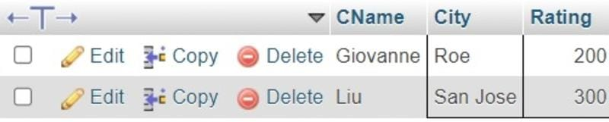

18)

SELECT * FROM salesperson;



19)

use tops;

CREATE TABLE SALESMAN(

SALESMAN_ID INT,

NAME VARCHAR(50),

CITY VARCHAR(50),

COMISSION FLOAT(3,2)

);

INSERT INTO SALESMEN (SALESMAN_ID, NAME, CITY, COMISSION)

VALUES (5001, 'James Hoog', 'New York', 0.15),

(5002, 'Nail Knite', 'Paris', 0.13),

(5005, 'Pit Alex', 'London', 0.11),

(5006, 'Mc Lyon', 'Paris', 0.14),

(5007, 'Paul Adam', 'Rome', 0.13),

(5003, 'Lauson Hen', 'San Jose', 0.12);

SELECT * FROM salesman;

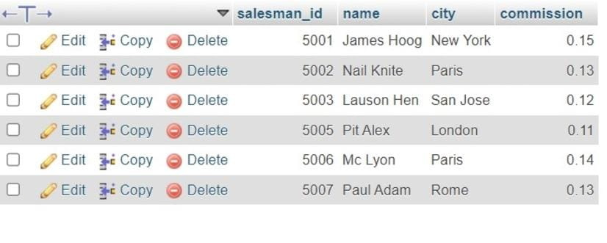

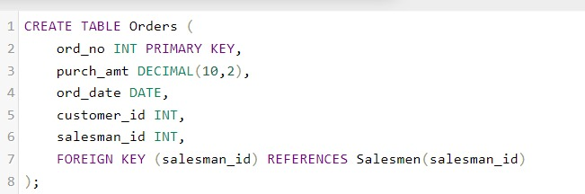

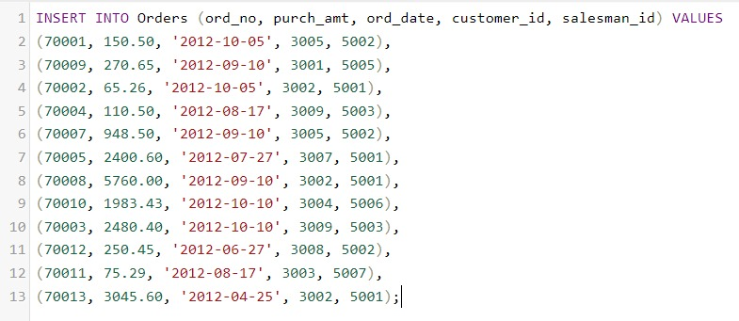

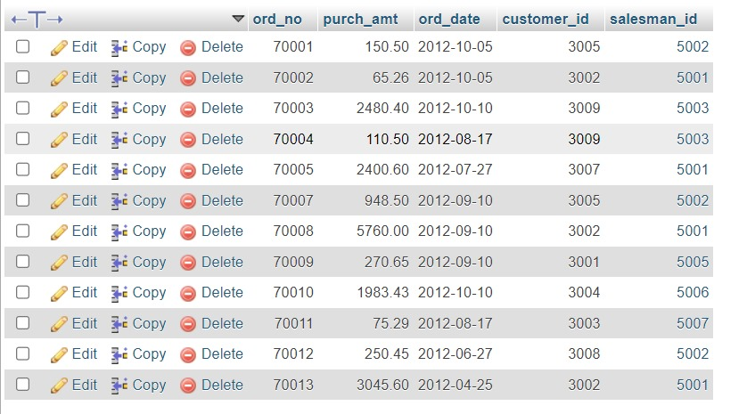

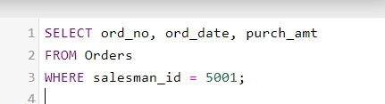 2